# Around the alter

There are three religious people around the alter, from the left, the sub-deacon, the celebrant and the deacon in order.

In front of alter, the celebrant who is wearing a red cape in the middle, he is holding up a golden plate in the mass.

The deacon is trying to tide up the celebrant’s cape in a kneeling pose.

The sub-deacon is praying in this scene.

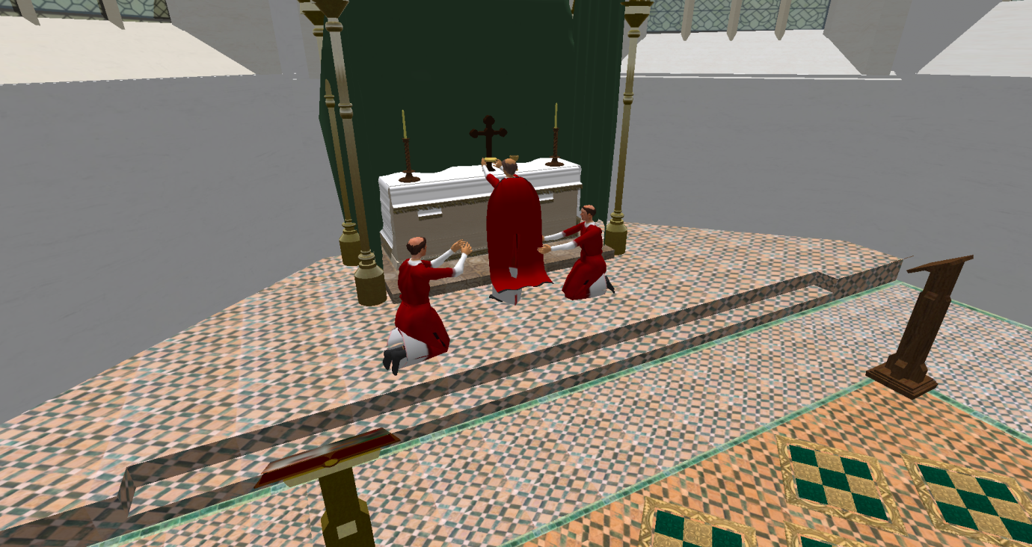

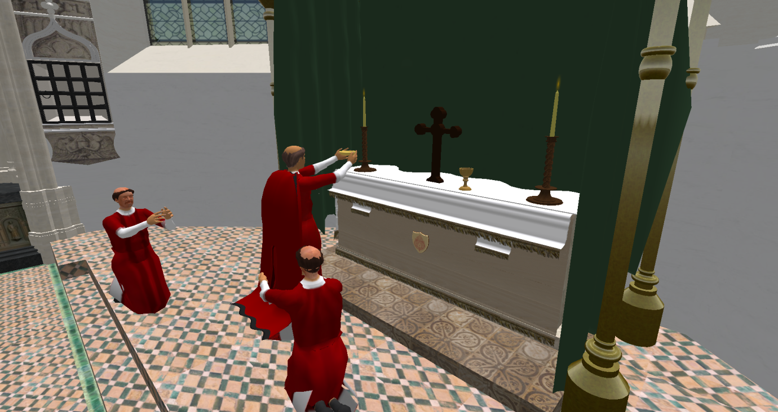

These scenes have referenced from several pictures like below (Picture1 – Picture3) :

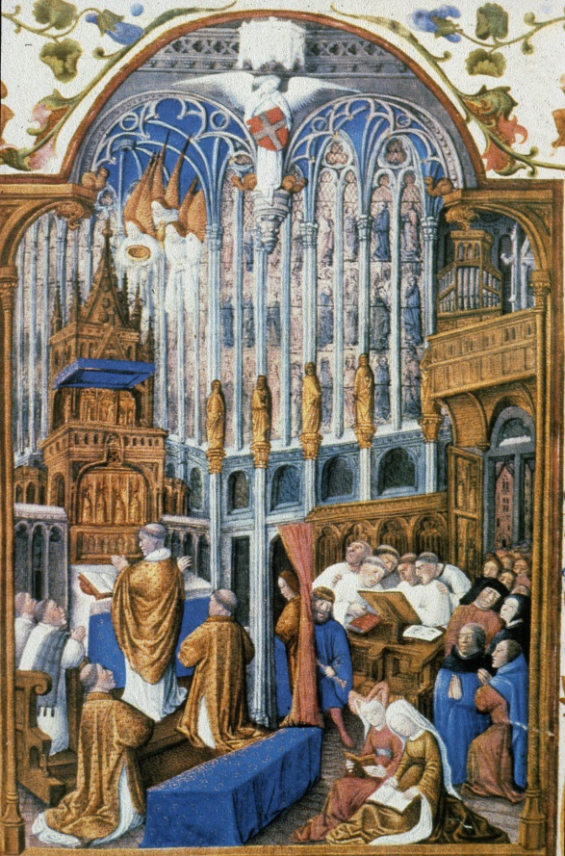

Picture1

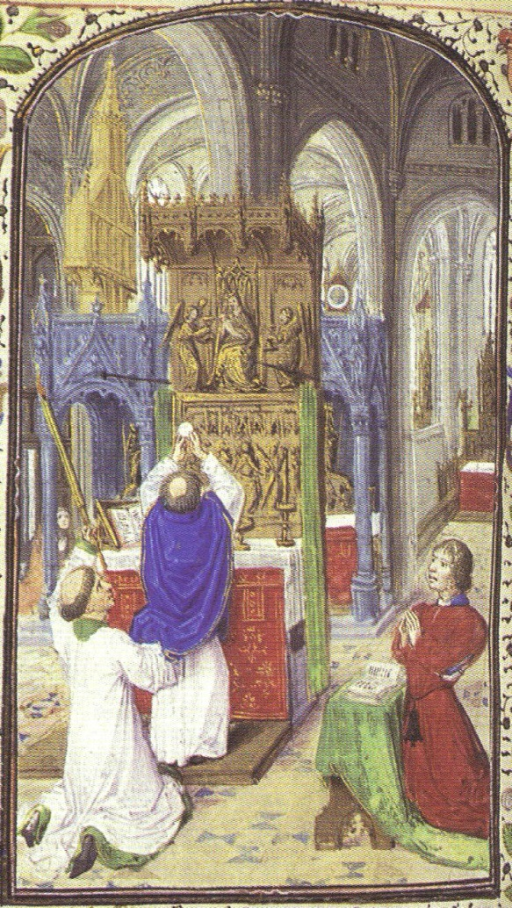

Picture2

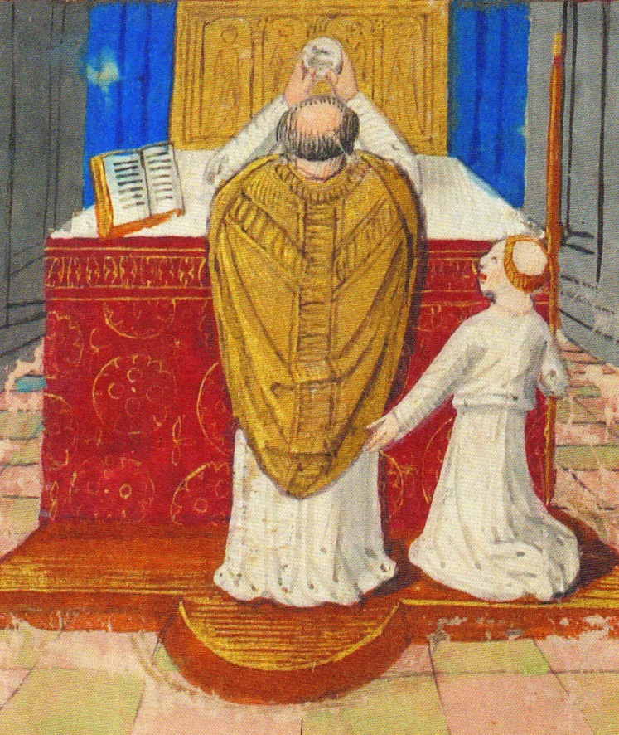

Picture3

# The Choir

In the mass, there is a choir, I assumed that the choir is made up with many canons and academics.

In choir, mainly there are three parts of location, right, left and middle.

Firstly, in the middle of the choir

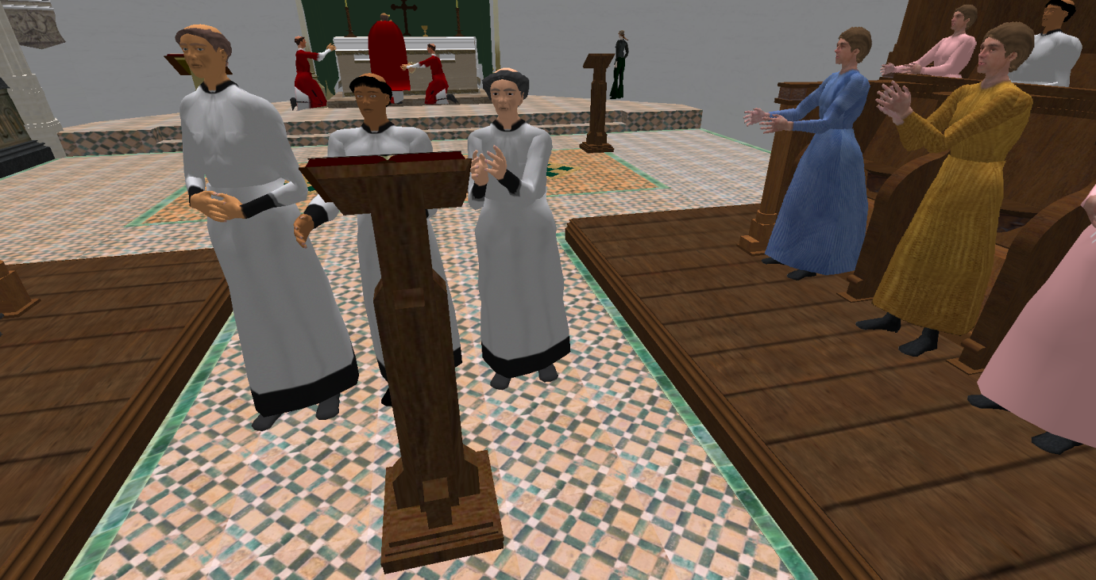



Picture4

Refer to above picture (Picture4),

The midlle part of the choir will be singing in a natural way.

Now, they are seperated, but it is needed to refer to the Picture4 as much as possible.

Secondly, in terms of the left and right side choir, refer to the below picture (Picture5), different poses of choir have made.

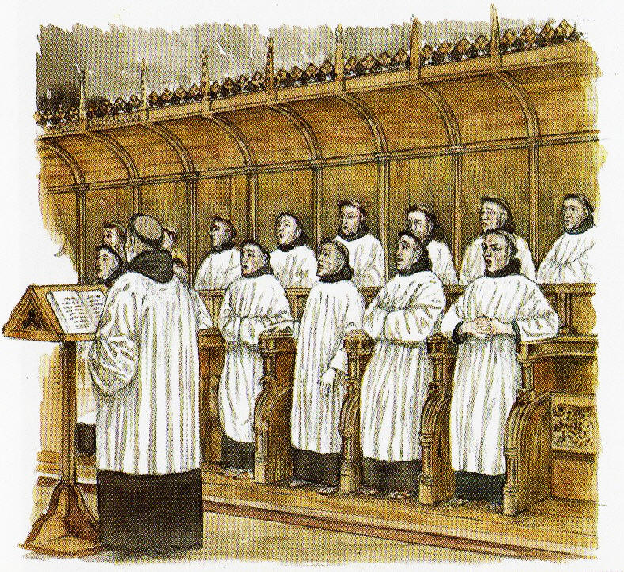

Picture5

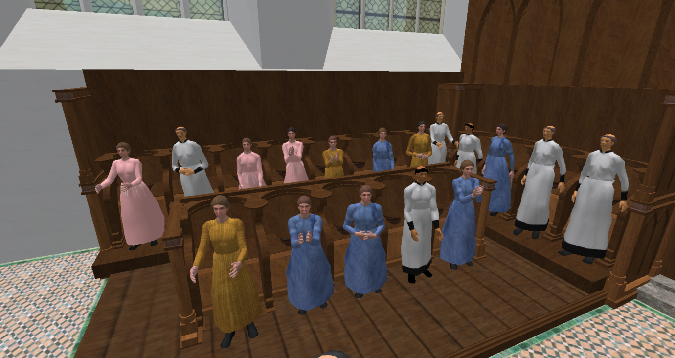

:: The left side of choir

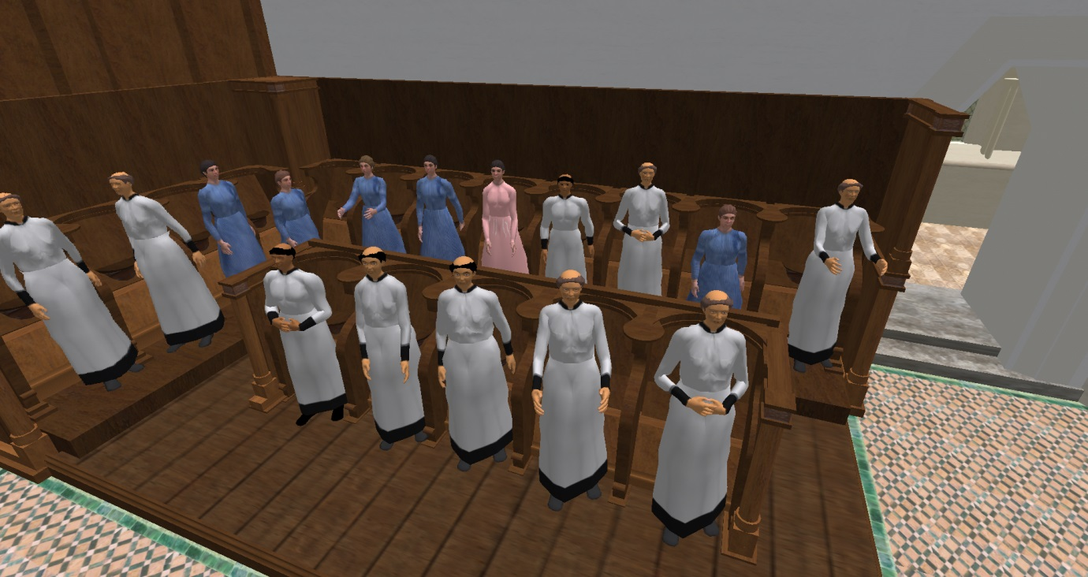

:: The right side of choir